To: Strathcona/Grandview-Woodland Business Improvement Association 1661 Napier Street Vancouver, BC

From: East Van Food Rescue Hub   
  
Date: March 21, 2025  
  
Subject: Proposal for Food Rescue Venture

**Introduction**

We are pleased to submit this proposal for the "East Van Food Rescue Hub," an initiative addressing food insecurity and food waste in Strathcona and Grandview-Woodland. By partnering with local businesses, we will collect surplus food and distribute it via a mobile service and an app-based reservation system. Our project aligns with the City of Vancouver’s Zero Waste 2040 strategy (City of Vancouver, 2025) and is designed to serve East Van’s diverse, budget-conscious population. With an initial budget of $100,000, we aim to ensure long-term sustainability through grants, sponsorships, and community fundraising.

To maximize impact, we are expanding our target demographic to include individuals experiencing homelessness, ensuring greater access for the most vulnerable while maintaining support for low-income families and students. Our hybrid model incorporates free meal distribution through shelters and community outreach teams.

**Background and Purpose**

**Local Context & Need**

Vancouver’s rising cost of living continues to impact food security, with food bank reliance up 15% in 2023 (CBC News, 2023). While Metro Vancouver disposes of over 100,000 tonnes of edible food annually, a significant portion comes from local cafes and grocers (Carman, 2022). Strathcona and Grandview-Woodland, home to approximately 40,000 residents, face increased financial pressures as rents have surged 20% since 2020 (City of Vancouver, 2021). Many residents, especially seniors, students, low-income families, and unhoused individuals struggle to afford nutritious meals, highlighting the urgent need for innovative food rescue solutions.

Recent studies from the Greater Vancouver Food Bank indicate that over 65% of recipients rely on food banks as a primary food source, demonstrating the increasing gap in food accessibility (Black & Seto, 2018). Additionally, homelessness in Vancouver increased by 15.5% between 2020 and 2023 (City of Vancouver, 2023), reinforcing the need for structured food relief services beyond traditional food banks.

**Demographics**

* **Population:** ~40,000
* **Median Household Income:** $60,000-$70,000 (below Metro Vancouver’s $93,000 average) (City of Vancouver, 2021)
* Over 50% identify as visible minorities, increasing demand for culturally relevant food options (Statistics Canada, 2021).
* Approximately 2,420 individuals are experiencing homelessness in Vancouver, with significant populations in Strathcona (City of Vancouver, 2023).
* Pedestrian-heavy Commercial Drive and Hastings Corridor present prime locations for mobile distribution (Chan, 2021).

**Existing Services & Gaps**

Demand has doubled at food banks across Canada, and the surge is being acutely felt in Metro Vancouver, with more people relying on emergency food services daily (Turner, 2024). While some businesses donate excess food independently, no structured system ensures efficient redistribution. Furthermore, unhoused individuals often lack access to traditional food banks due to ID requirements, transportation barriers, or restricted hours. The East Van Food Rescue Hub bridges this gap, integrating technology with community engagement to streamline food recovery and equitable distribution.

**Proposal**

The East Van Food Rescue Hub presents a mobile service designed to address food insecurity by collecting surplus food, such as day-old pastries, overstocked produce, and unsold meals from local eateries, and distributing it through pop-up markets.   
 **Operational Model**

**Food Collection**

**Collection Process:**

Surplus food will be collected from participating businesses three times per week, including cafes, grocers, restaurants, and bakeries. The collected food will primarily consist of unsold items such as day-old pastries, surplus produce, and prepared meals that would otherwise go to waste.

To ensure operational efficiency, businesses will be scheduled for pickup based on proximity and food availability. The food collection process will be executed using a branded cargo van, which will enhance visibility in East Vancouver, helping raise community awareness about food rescue initiatives.

**Storage & Sorting**

**Facility Setup:**

A **500 sq. ft.** rental space will serve as the central hub for food storage and sorting. It will be equipped with:

* **Refrigeration units**
* **Shelving**
* **A designated sorting area**
* **A waste reduction station**

**Sorting Process:**

Food will be categorized into **perishable** (e.g., fruits, vegetables, dairy) and **non-perishable** (e.g., canned goods, bread) items. Items with a short shelf life will be prioritized for immediate distribution, while non-perishable goods will be stored strategically to minimize waste. To streamline operations, a **tracking system** will be implemented.

**Distribution**

**- Pop-Up Markets:**

Bi-weekly pop-up markets will be hosted in **high-foot-traffic locations** such as Grandview Park, Britannia Centre, and other key community hubs in East Vancouver. These events will allow individuals to purchase rescued food at an affordable cost, typically **$5 per “rescue bag.”** Each **rescue bag** will contain a curated selection of high-quality surplus food items, ensuring nutritional variety.

**App-Based Reservations:**

A **custom-designed mobile app** will be developed for efficient distribution. Users will be able to:

* **Reserve** their $5 “rescue bags” in advance to reduce wait times.
* **Select a preferred pickup time** to prevent overcrowding.
* **Track real-time food availability.**
* **Receive event notifications** and updates about upcoming pop-ups.
* **Donate towards rescue bags** for those in need through an integrated donation feature.

**Equitable Access:**

The **reservation system** will prevent long lines and ensure fair access to food. To address digital access barriers, a **walk-in option** will be available for those without smartphones. Additionally, a **pay-it-forward system** will allow customers to cover the cost of a bag for someone else.

**Direct Outreach to Unhoused Populations:**

To ensure unhoused individuals have access to food, the initiative will:

* Partner with **shelters, outreach teams, and community organizations** to distribute free meals directly to encampments and high-need areas.
* Utilize the **cargo van for direct food deliveries** to these locations.
* Develop a **voucher program** allowing unhoused individuals to redeem free rescue bags at pop-up markets.

**Community Engagement**

**Food Swap Fridays:**

A bi-weekly event at **Grandview Park** will encourage community members to trade homemade dishes, leftovers, or surplus food.

**Safety Protocols:**

* All swapped food will be **inspected** by the food safety team.
* Participants will be required to **follow hygiene guidelines** and package items securely.

**Unique Selling Points**

**Mobility & Accessibility:**

Unlike static food banks, the **East Van Food Rescue Hub** is a mobile service, allowing for flexibility in reaching underserved communities.

**Branded Cargo Van:**

The cargo van will serve dual purposes:

* **Transporting food safely**
* **Acting as a moving advertisement**

**Community Collaboration & Benefits**

**Business Partnerships:**

The initiative will collaborate with **local businesses along Hastings and Commercial Drive.** In exchange for food donations, businesses will benefit from:

* Increased foot traffic at pop-up markets.
* A chance to participate in shared waste reduction programs.
* Recognition as **food sustainability partners**.

**Boosting the Local Economy:**

* Pop-up markets will attract **new customers** to nearby businesses.
* Participating businesses will receive **eco-conscious branding benefits**

**Waste Reduction Collaboration:**

* Partnerships with **local composting programs** will divert inedible food scraps from landfills.

**Competitive Advantage**

**Filling an Urgent Gap:**

Traditional food banks and meal programs are **overwhelmed**, and many individuals face barriers to accessing food due to:

* **Limited operating hours.**
* **Stigma associated with food assistance programs.**
* **Physical inaccessibility of food bank locations.**

The East Van Food Rescue Hub **eliminates these barriers** by:

* **Offering mobile distribution.**
* **Leveraging technology for streamlined food reservations.**
* **Providing a dignified food access experience.**

**Tech-Integrated, Community-Driven Approach:**

The initiative’s **app-based model** ensures efficiency, while community events like **Food Swap Fridays** foster social connections and sustainability.

**Scalability & Future Expansion:**

* Future plans include **expanding to additional neighborhoods** in Vancouver.
* Exploring **partnerships with urban farms** for fresh produce sourcing.
* Introducing a **subscription model** where users can prepay for multiple rescue bags at a discounted rate.

**Implementation Timeline**

|  |  |  |
| --- | --- | --- |
| **Phase** | **Timeline** | **Key Milestones** |
| Planning & Partnerships | Month 1-2 | Secure business partners, confirm permits, engage shelters |
| Infrastructure Setup | Month 3 | Acquire van, lease storage space, develop app |
| Pilot Launch | Month 4 | Begin small-scale operations, refine logistics, test homeless outreach |
| Full Launch | Month 6 | Expand to 10+ business partners, 500 households, 200+ unhoused individuals |
| Evaluation & Scaling | Month 12+ | Assess impact, explore additional funding |

**Budget Overview**

|  |  |
| --- | --- |
| **Expense** | **Cost** |
| Vehicle (used cargo van) | $18,000 |
| Rent & Utilities (500 sq ft facility) | $21,600/year |
| Equipment (coolers, shelves, bins) | $5,000 |
| App Development | $12,000 |
| Marketing & Outreach | $6,000 |
| Staff (part-time coordinator) | $8,000 |
| Food Safety & Compliance Training | $3,000 |
| Legal & Permits | $6,000 |
| Direct Outreach to Unhoused Communities | $8,400 |
| Contingency | $12,400 |
| **Total Estimated Setup Cost** | **$82,400** |
| **Total Estimated Budget** | **$100,000** |

**Benefits of the Initiative**

**During Implementation**

* Immediate reduction in food waste from participating businesses
* Engaging volunteer and community support, strengthening local networks

**Upon Completion & Long-Term Impact**

* **Food Waste Reduction:** Prevents 5 tonnes of edible food from being discarded annually
* **Community Impact:** Provides affordable food to 500+ households and 200+ unhoused individuals monthly
* **Economic Benefits:** Supports local businesses by reducing disposal costs and boosting foot traffic
* **Environmental Gains:** Aligns with Vancouver’s Zero Waste 2040 goals, promoting sustainability
* **Social Cohesion:** Encourages cultural food exchanges, fostering stronger community ties

**Authorization & Next Steps**

We deeply appreciate the opportunity to present this proposal and firmly believe in the transformative impact of the East Van Food Rescue Hub. By addressing food insecurity and waste through an innovative, community-driven approach, we aim to create lasting positive change in Strathcona and Grandview-Woodland.

We welcome the opportunity to discuss this proposal further, explore potential collaboration, and refine our approach based on your insights. We are eager to take the next steps and look forward to your guidance on how best to proceed.

Thank you for your time, support, and consideration.

**Reference List**

1. Black, L.J, Seto, D. (2018), Examining Patterns of Food Bank Use Over Twenty-Five Years in Vancouver, Canada. National Library of Medicine.<https://pmc.ncbi.nlm.nih.gov/articles/PMC7608732/>

2. Carman, T. (2015). Metro Vancouver challenges residents to stop wasting food. *Vancouver Sun*. [https://www.vancouversun.com](https://www.vancouversun.com/)

3. Chan, K. (2021). Vancouver city council approves motion for “pedestrian-first” section of Commercial Drive. *Daily Hive*.<https://dailyhive.com/vancouver/vancouver-commercial-drive-pedestrian-first>

4. City of Vancouver. (2021). *Vancouver census data 2021*.<https://dailyhive.com/vancouver/vancouver-commercial-drive-pedestrian-first>  
5. City of Vancouver. (2023). *2023 homeless count*. Vancouver.ca. Retrieved from<https://vancouver.ca/people-programs/homeless-count.aspx>

6. City of Vancouver. (2025). *Zero Waste 2040*. Vancouver.ca.<https://vancouver.ca/green-vancouver/zero-waste-vancouver.aspx>

7. Chan, K. (2021). Vancouver city council approves motion for “pedestrian-first” section of Commercial Drive. *Daily Hive*.<https://dailyhive.com/vancouver/vancouver-commercial-drive-pedestrian-first>

8. Food Banks Canada. (2023). *HungerCount 2023 report*.<https://foodbankscanada.ca/hungercount-2023/>

9. Globe and Mail. (2023). Second Harvest rescues record 20 million pounds of food in 2022. *The Globe and Mail*. [https://www.theglobeandmail.com](https://www.theglobeandmail.com/)

10. Statistics Canada. (2021). *Census profile: Vancouver CMA*.<https://www12.statcan.gc.ca/census-recensement/2021>

11. Statistics Canada. (2023). *Consumer Price Index: Food prices, 2022*.<https://www.statcan.gc.ca>

12. Strathcona/Grandview-Woodland Business Improvement Association. (2025, March 21). *East Van Food Rescue Hub*. Retrieved from <http://www.sgbusiness.ca/food-rescue>  
The Georgia Straight. (2023). East Van’s activist spirit thrives in community projects. *The Georgia Straight*. [https://www.straight.com](https://www.straight.com/)

13. Turner, A. (2024). Vancouver food bank feeling demand as Food Banks Canada reports doubling of users. *CTV News*.<https://www.ctvnews.ca/vancouver/article/vancouver-food-bank-feeling-demand-as-food-banks-canada-reports-doubling-of-users/>

Appendix  
  
Cargo Van

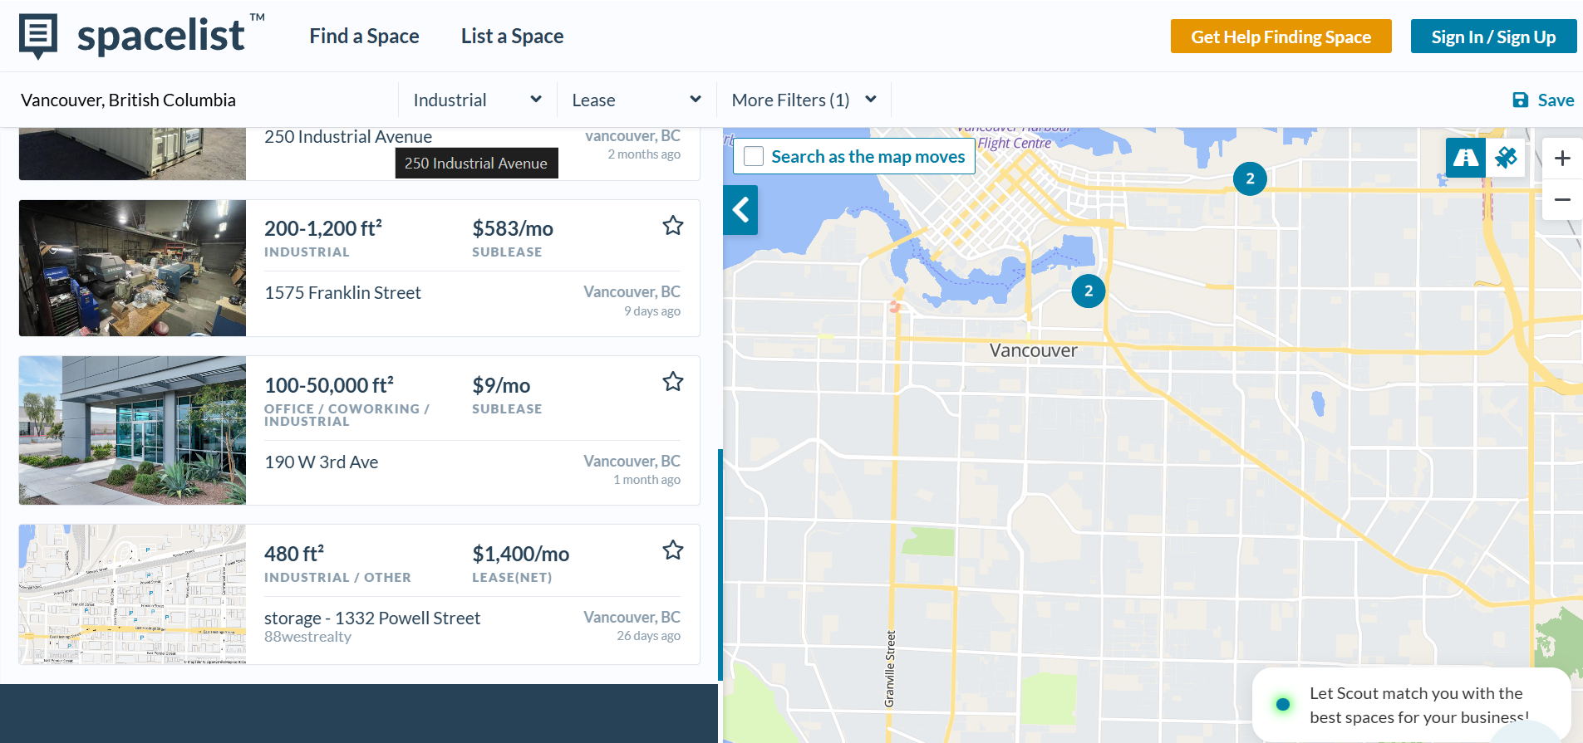**Rent and Utilities:** 500 sq ft near Hastings , approximately $1,800/month  
Rent: $1500/ month  
Electricity, Heater and other utilities: $300/month  
  
Cooler

Shelves  
